Car Rental Application

**Description of features of the application**

* This is a platform that allows car owners to show their available cars to their customers and let them rent cars. The app allows owners to type and store their car model, quantity, and setting rental prices, as well as modify them. After the customer returns the car, the owner will receive a return on the earning record.
* The app also allows customers to view the owner's car model and make reservations for the car. Customers can also view their current and previous booking records.

**Description of how data structures are being applied and their suitability.**

1. **Linked lists**
   * ModelData
   * VehiclesData
   * CustomersData

This data are store in a linked lists data structure with sorted method. It is easy to code and simple to maintain.

1. **Queues**
   * BookingsData

The data structure of the queue system is a first-in first-out form. This is a good thing for car bookings, the latest booking will be the last to come and earlier bookings will be ranked first, so searching data from the queue system for earlier booking customers will be faster.

1. **Stacks**
   * PriviousBookingsData

In order for the owner to be able to view the revenue record, the owner always wants to get the latest information, and the old record will be useless. Therefore, the data structure in the form of a stack is very suitable for the owner. It is a last-in first-out system. The oldest booking record always at the bottom. When searching the top latest information will get it first.

**Description of the data and format in the various files.**

* + Car model and selling detail -> ModelData.xlsx
  + Individual car info and ID -> VehiclesData.xlsx
  + Customers NRIC and Name -> CustomersData.xlsx
  + Booking ID, date & cost -> BookingsData.xlsx
  + Pass booking record -> PriviousBookingsData.xlsx

(Microsoft Office Excel file)

**Description of various error handling and concurrency mechanism incorporated**

* + Most error handling use on the user input. To check value that the user is entering and return a message to guide the user enter correct value and again.
  + There is a defer recover code @ the main function for any panic case that happen for the app runtime and start from main menu again.

**Instructions on how to run your application**

**Run the app requirement**

1. **Require to open command prompt with installed go compiler.**
2. **At command prompt to key “go run .” and enter.**
3. **Then, follow the step below.**

**Pages for Owner’s Customers**

1. **Search Car for Rent**

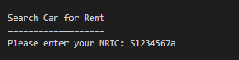

* 1. The customer needs to enter his NRIC to book a car.

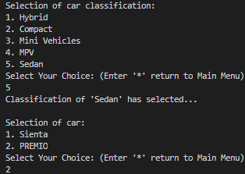

* 1. Then show the customer the category and choice of the car

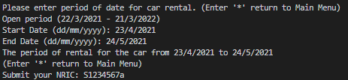

* 1. The customer needs to provide period of rental.

1. **Current Booking**

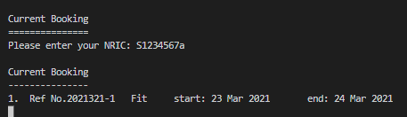

* 1. NRIC is required to match the current booking that have made



* 1. Then show customer his current booking

1. **Previous Booking Record**

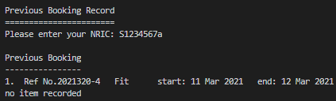

* 1. NRIC is required to match the previous booking data



* 1. Then show customer his previous booking

**Pages for Owner**

1. **Add Model Detail**

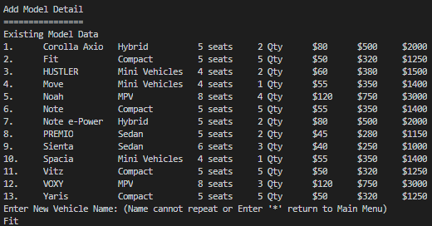

* 1. Firstly, show owner with existing data.

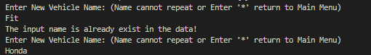

* 1. Ask owner to enter a new name of the car. Owner is not allowed to add name the existing have.

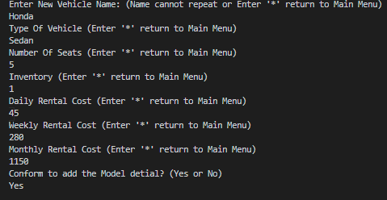

* 1. Ask owner to enter the new car details.
  2. Reconfirm owner the car details to add.

1. **View or Modify Model Vehicle’s Details**

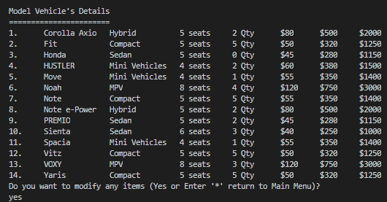

* 1. Show owner with existing data.
  2. Ask owner whether he want to make change of the existing data.

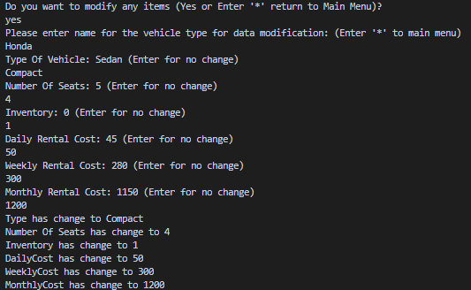

* 1. Owner requires entering the car name in order to change the details.
  2. Changes made show in the end.

1. **Delete of The Model Vehicle**

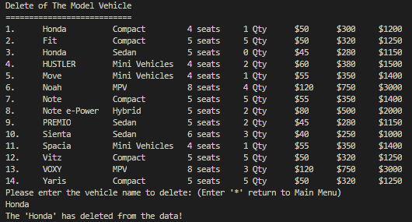

* 1. Show owner with existing data as well.
  2. Request owner key in the name of the model to delete. Show deleted end of the code.

1. **View Earning From Previous Booking**

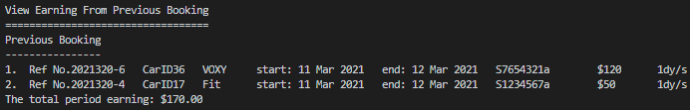

* 1. It is a report of total earning for past rental record.

1. **Exit and Save Files**

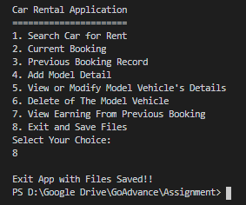

Save all data from the data structure to excel files.